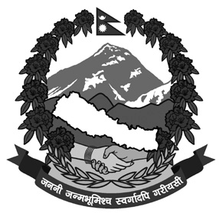

(As per the permission granted by the Government of Nepal)
REGISTRATION FORM
for
Trekker's Information Management System (TIMS)

TIMS Card No

To,
The Nepal Tourism Board,

You are kindly requested to record my personal detail for the record management purpose as per the Trekker's Information Management System (TIMS) to meet the requirements.

PHOTO

Trekking Area
Trek Entry Date |  | Trek Entry Point
Trek Exit Date |  | Trek Exit Point
Route of Trekking
Note: Trekking Areas are: (i) Annapurna (ii) Langtang (iii) Everest

Personal Details
Full Name (in Block Letters)
Nationality
City
Gender
Date of Birth

Passport No
Email
Visa No. |  | Issue Date |  | Expiration Date

Emergency Contact Details:
In Nepal (if any) |  | In Home Country (Mandatory)
Contact Person |  | Contact Person
Position |  | Relation
Name of Company |  | Mobile No.
Mobile No. |  | Office / Home Tel No.
Office / Home Tel No. |  | Address
Address

Insurance Policies
Insurance Policy No. |  | Hotline:
Coverage Details

Commitment from Free-Individual Trekker (FIT)
I hereby certify that I understand my obligation as a Free Individual Trekker to take care of all my needs on the trek route on my own and if any support service is required for me. I shall purchase / arrange it only through the government registered trekking agencies under the prevailing regulation.

In case of emergencies, I also understand that it is my responsibility to pay all the bills incurred in connection with same.

___________________________
Applicant’s Signature Date:

Note: Nepal Tourism Board (NTB) has also authorised Trekking Agencies’ Association of Nepal (TAAN) to issue this form.)



